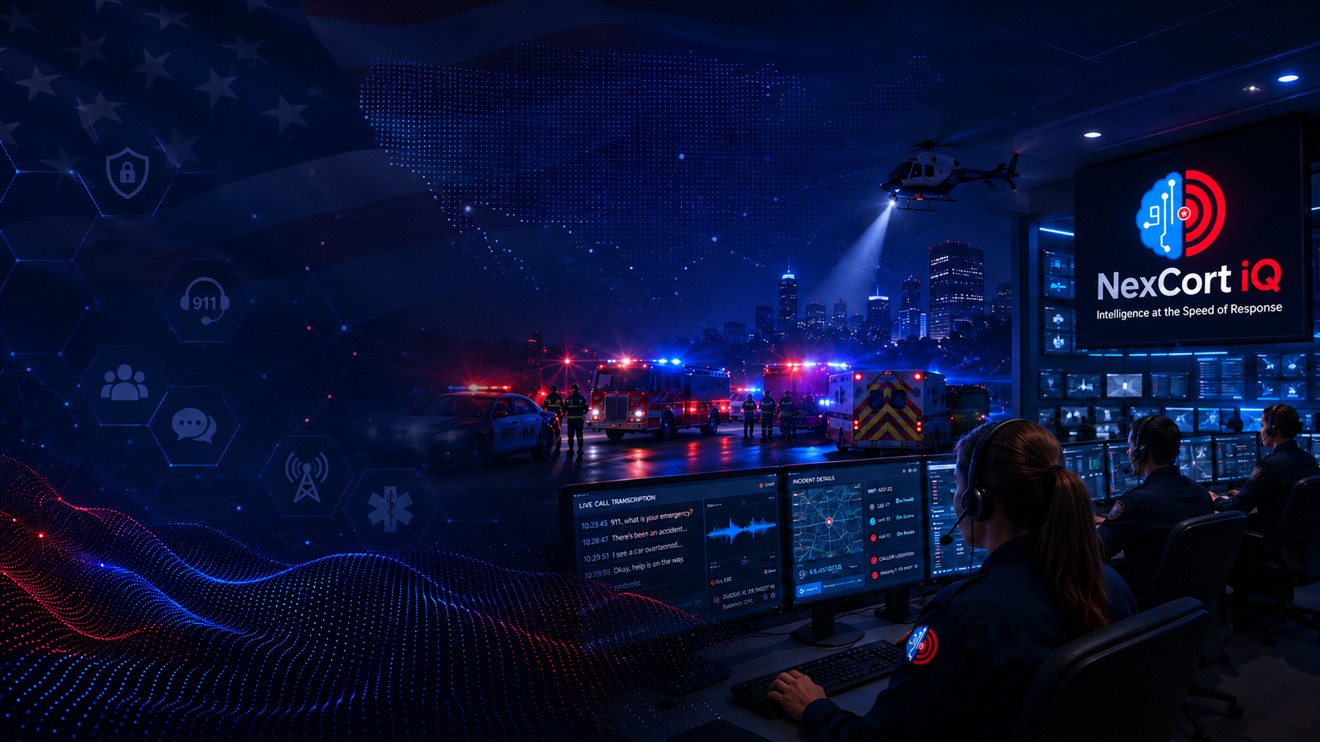

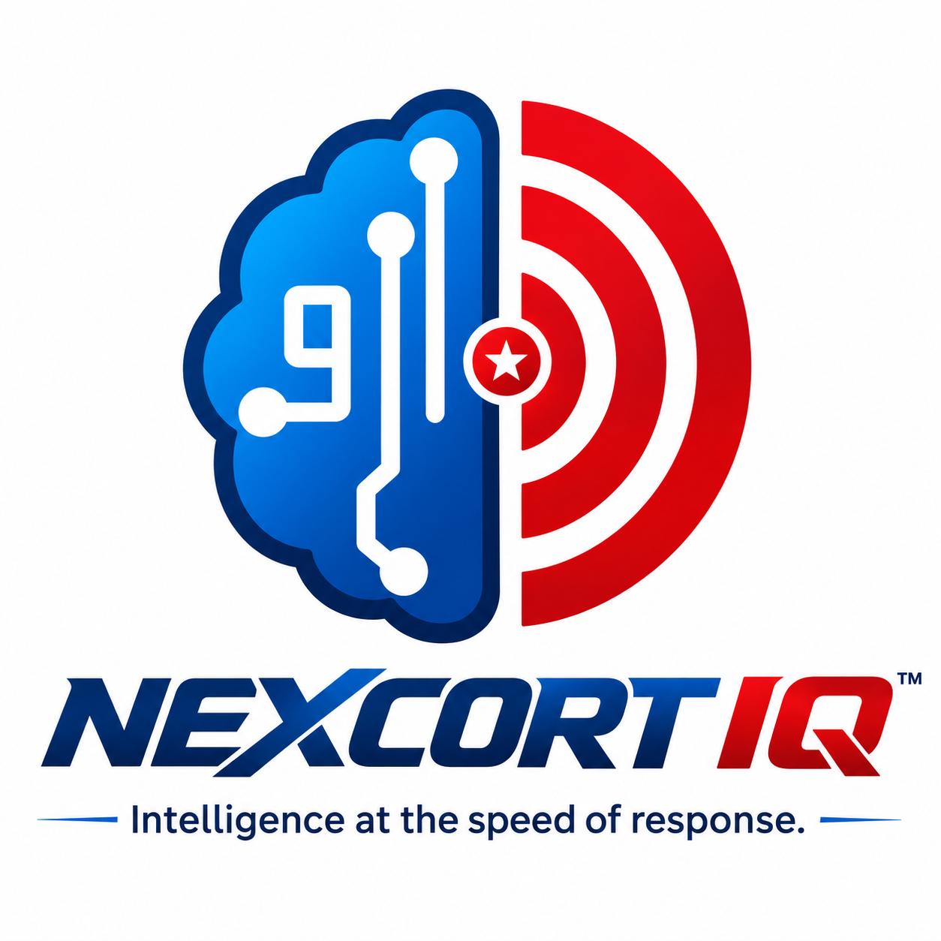

SALES GUIDE
NexCort iQ™ · Intelligence at the speed of response
October 2026 · CONFIDENTIAL — INTERNAL USE ONLY
Apps on Demand LLC· www.nexcortiq.us · (404) 520-1747

1 · PLATFORM OVERVIEW

NexCort iQ is a real-time public safety intelligence platform built on AWS that enhances — but does not replace — 911 dispatch centers, CAD systems, dispatchers, or medical direction. Legal entity: Apps on Demand LLC, a Wyoming LLC.
Tagline: Intelligence at the speed of response.
Marketing: www.nexcortiq.us | Ops console: app.rapidcortex.us | Phone: (404) 520-1747 | Email: jeff@nexcortiq.us
Infrastructure: AWS us-east-1 — Lambda, DynamoDB, API Gateway, ECS Fargate, Cognito, KVS, Bedrock, Transcribe, Translate, Amazon Location Service
Compliance: CJIS-aware design · SOC 2 Type II documentation in progress · MFA + RBAC on every role · 7-year audit retention · KMS encryption at rest
Always true: NC iQ enhances operations. A human stays in the loop. CAD write-back stays fail-closed unless an agency is explicitly enabled via signed addendum.

Who We Serve
Vertical | Primary Customers | Tagline
NC 911 | PSAPs · 911 ECCs · Law Enforcement · Fire/EMS Dispatch | Real-Time Intelligence. Better Outcomes.
NC Campus | Universities · Colleges · K-12 · Campus Safety Departments | Safer People. Stronger Campuses.
NC Venue | Stadiums · Arenas · Convention Centers · Concert Venues · Airports | Safer Events. Smoother Operations.
NC Transit | Transit Authorities · Bus & Rail · Ferry Systems | Safer Riders. Stronger Operations.
NC Hospital | Hospitals · Health Systems · EMS Coordination Centers | Coordination at the Speed of Care.

2 · CORE CONCEPTS & DEFINITIONS
Know these terms fluently before your first call with a PSAP Director, Safety Chief, or IT Director.
Public Safety Infrastructure
Term | Definition
PSAP | Public Safety Answering Point — the 911 call center. ~6,000 in the US. Primary PSAPs answer first; secondary PSAPs handle overflow or specialized calls.
ECC | Emergency Communications Center — same as PSAP, preferred in some regions.
CAD | Computer-Aided Dispatch — the core dispatch system. Key vendors: Tyler Technologies, CentralSquare, Hexagon, Spillman.
NG911 / NG9-1-1 | Next Generation 911 — IP-based upgrade to analog 911. Enables text-to-911, media sharing, and richer location data.
ESInet | Emergency Services IP Network — broadband backbone carrying NG911 traffic between PSAPs.
i3 Standard | NENA technical standard for NG911 system-to-system interoperability. NC iQ is i3-aware.
NENA / APCO | 911 trade bodies. NENA sets technical standards; APCO focuses on training and professional certification.
CJIS | Criminal Justice Information Services — FBI security policy governing access to criminal justice data. NC iQ is CJIS-aware (not yet CJIS-certified — language matters).
Clery Act | Federal law requiring US colleges to disclose crime statistics and maintain a daily crime log. NC Campus: Clery tooling for higher-ed; K-12 uses Daily Incident Log and School Safety Report (not Clery ASR).
10DLC | FCC registration for A2P SMS messaging. NC origination number (+1 319-835-8230) is 10DLC-registered.

NexCort iQ Platform Terms
Term | Definition
NC Translate | Bidirectional real-time AI voice translation between telecommunicator and caller across 100+ languages. No interpreter bridge, no hold queue, no third party on the line. Available in the PSAP console and as field/ops Translate sessions for campus, venue, transit, and clinical contexts.
NexiQ Vision™ | AI scene intelligence over live camera feeds (agency cameras plus citizen share paths such as Ring/Nest/Wyze). Observations and vision transcripts surface to authorized roles in the incident console. Human-in-the-loop — Vision assists; it does not autonomously enforce.
CAD Assist | AI-suggested CAD field values shown to the dispatcher for review before any submission. Read enrichment is always available; write-back into native CAD is fail-closed unless a signed addendum and explicit config enable it.
Call Assist | Separate non-emergency product (Amazon Connect + Lex + Bedrock + Polly). Roles: CALL_ASSIST_ADMIN, CALL_ASSIST_SUPERVISOR, CALL_ASSIST_OPERATOR. Users never land on the 911 dispatcher console. Emergency mid-call handoff uses hardcoded TRANSFER_911 that cannot be suppressed.
Signal Color System | Semantic 7-color priority system used consistently across PSAP, campus, venue, transit, and hospital consoles so priority language stays the same when staff move between verticals.
Surge View | Clusters related 911 calls by time, place, and type to surface mass-casualty, weather, or multi-incident patterns as they emerge — often before anyone formally declares a major incident.
Video Assist | Dispatcher-requested live video from the caller’s smartphone via WebRTC. No citizen app install. Designed for seconds-to-visual, not investigative playback.
Agency Share | Consent-based, dual-admin-approved incident awareness between partner agencies. Cross-tenant reads are blocked unless Agency Share is enrolled. Typical list price reference (internal): $1,500/month per agency — confirm current rate card before quoting.
NC Connect | Agency camera integration (Cameras / Camera AI / NexiQ Vision™) linking existing ONVIF/RTSP/WebRTC cameras into the incident console. Distinct from citizen Nest/Wyze/Ring share flows.
QR / NFC Codes | Physical codes at seats, campus signs, vehicle doors, gates. Scan or tap opens a pre-filled incident/tip form — no app required. Free Community Connect = one zone; paid Multi-zone QR/NFC expands coverage.
RBAC | Role-Based Access Control. Every permission is agency-scoped. Product vertical roles (VENUE_*, CAMPUS_*, HOSPITAL_*, TRANSIT_*, CALL_ASSIST_*) stay isolated from PSAP dispatcher consoles.
Seat | A licensed user slot. Dispatcher seats and Admin/Supervisor seats are counted and billed separately. Confirm overage rules for the plan tier before quoting.
Fail-closed | Default safety posture for CAD write-back and Call Assist emergency handoff. Features stay off or transfer to 911 unless explicitly enabled; configuration cannot silently weaken those paths.
Human in the loop | Non-negotiable product rule: AI suggests; humans decide. Never tell a buyer that NC iQ autonomously dispatches, diagnoses, or writes to CAD without review.
Sales contractor portal | salescontractor role: Sales Portal + curated RC Admin CRM/intel surfaces. Pricing Catalog and Service Catalog show features only — no list prices. Tenant admin, billing, feature flags, and audit stay with rcadmin.

3 · CORE PLATFORM FEATURES
NC 911 Dispatcher Workspace — the flagship product

All features below are in the 911 dispatcher console. Verticals inherit relevant subsets and add their own. For offerable SKU-level definitions (including free wedges and never-free rules), see Section 10 — Offerable Feature Catalog. Sales contractors should use the in-product Pricing Catalog for the same definitions without prices.

Dispatcher Workspace
Feature | What It Does | Sales Emphasis
Live Dispatcher Console | Unified live workspace: incident queue, intake card, caller panel, location, media, and AI assists on one screen. Built to sit beside CAD — not replace telephony or CAD. | Single pane of glass — no tab-switching mid-call.
Live Speech-to-Text Transcription | Word-by-word real-time transcription of the 911 call into the console. Feeds coaching, QA, disposition summaries, and audit. Foundation layer for nearly every AI feature. | Every word captured — no post-call recall required. Never offer as free.
AI Analysis & SOP Coaching | AI reads the live transcript and surfaces protocol reminders, SOP steps, discrepancy flags, and confidence cues. Advisory only — dispatcher judgment remains authoritative. | Reduces cognitive load on every call without autopilot claims.
NC Translate | Bidirectional live voice translation (100+ languages) so one telecommunicator can work non-English callers without an interpreter hold. Also available as field/ops Translate outside the ECC. | One dispatcher handles any language — no interpreter hold.
Video Assist | Live WebRTC video from the caller’s phone into the console. No app install. Complements caller media uploads when the dispatcher needs eyes-on immediately. | Dispatcher sees what the caller sees in seconds.
Caller Media Intake | Secure SMS/web link for photos, short video, and location media into the incident record with audit trail. No citizen app. Evidence can arrive before units. | Scene intel at intake — strong for DV, fire, MVC, campus tips.
Live Caller Location | GPS/SMS/ping location with accuracy radius, trail history, and Live/Stable/LOST status so confidence is visible — not just a pin. | Location confidence shown in real time.
Silent Text / SMS Location | Passive SMS location path for callers who cannot or will not speak (DV, hostage, stealth). Complements spoken intake without forcing voice. | Handles silent / cannot-speak scenarios without abandoning location.
Surge View | Clusters related calls by time, place, and type to reveal MCI/weather/multi-incident patterns as they form for supervisors and command. | Supervisor sees mass-casualty patterns as they emerge.
Disposition Summaries | AI-generated post-call summaries for incident documentation. Agency-measured time savings — do not guarantee a fixed percentage reduction. | Cuts after-call write-up effort; never promise a specific %.
RCS Monitor | Monitors configured radio talk groups and surfaces critical traffic alongside call activity. Confirm live radio monitoring SKU availability before demoing. | Radio and call activity in one view — confirm SKU first.
Cross-Jurisdiction Shares | Real-time incident awareness with partner agencies under Agency Share consent and dual-admin approval. Not a silent cross-tenant feed. | Mutual aid response is faster and better informed — with consent.

CAD, NG911, and Integrations
Feature | Notes
CAD Assist (Read) | One-way CAD enrichment into the NexCort context panel (units, nature, related activity). Always the safe first integration step — no CAD writes.
CAD Nature-Code Mapping | Maps NexCort incident types to the agency’s native CAD nature codes so assisted posting uses CAD-native vocabulary.
CAD to Native CAD Posting | Optional write-back of dispatcher-reviewed fields into native CAD. Fail-closed by default; requires signed addendum + discovery. Never include full write-back in pilot base price.
NG911 Assist | i3-aware assist packs: diversion, EIDO/additional data, NG911 metrics. Complements ESInet programs — does not replace telephony.
Channels & Talk Groups | Admin configuration for agency channels/talk groups. Live radio monitoring may be a separate SKU — confirm before promising floor monitoring.
Physical Security Ingest | Ingests access-control and physical security events into the console so door/alarm context appears next to the incident.
Cognito Auth (SSO Ready) | Amazon Cognito with MFA enforced. Enterprise SSO via SAML/OIDC. Roles scoped per agency; product verticals isolated from PSAP seats.

Supervisor, QA, and Command
Feature | What It Does
Active-Call Floor Monitoring | Supervisor view of live calls and dispatcher status in real time, with monitoring indicators suitable for QA and coaching — not silent spying without audit.
QA Scoring and Scorecards | AI-assisted quality scoring against configurable rubrics tied to transcripts and call timelines. Replaces ad-hoc monthly sampling.
Coaching Notes | Supervisor attaches coaching notes to flagged calls; notes surface to the dispatcher at review so feedback is tied to the actual call.
War Rooms | Major-incident command workspace with shared situational awareness for authorized command staff without putting everyone in a dispatcher seat.
Stakeholder / Public Status Pages | Shareable status pages for partners/public during incidents. Confirm which audiences and branding the agency needs before promising.
Post-Incident Reviews | Structured debrief combining timeline, transcript, media, and QA score for after-action learning.
SLA Thresholds and Backlog | Configurable aging/SLA alerts that flag calls or tips past response windows so backlog does not hide in the queue.
Predictive Staffing | AI-suggested staffing adjustments from volume patterns. Confirm SKU availability before demoing — do not invent readiness.
Scenario Center | Opt-in training/simulation mode. Isolated from live operational data. Good for change management; not a production substitute.

4 · VERTICAL SOLUTIONS — NC 911
Built for Emergency Communications Centers

Who buys it: PSAP Directors · 911 Directors · ECC Managers · County/City IT Directors
What it delivers: The full dispatcher workspace — live transcription, AI coaching, NC Translate, caller location, media intake, Video Assist, Surge View, CAD read assist (write-back optional), supervisor QA, command tools, and war rooms. Flagship product; other verticals inherit relevant subsets.
Key differentiators: CJIS-aware design · CAD-agnostic · No telephony rip-and-replace · Fail-closed CAD write-back by default · 100+ language translation included in Professional+
Pricing model: Per seat/month. Essential → Professional → Command → Enterprise W/ available add-ons

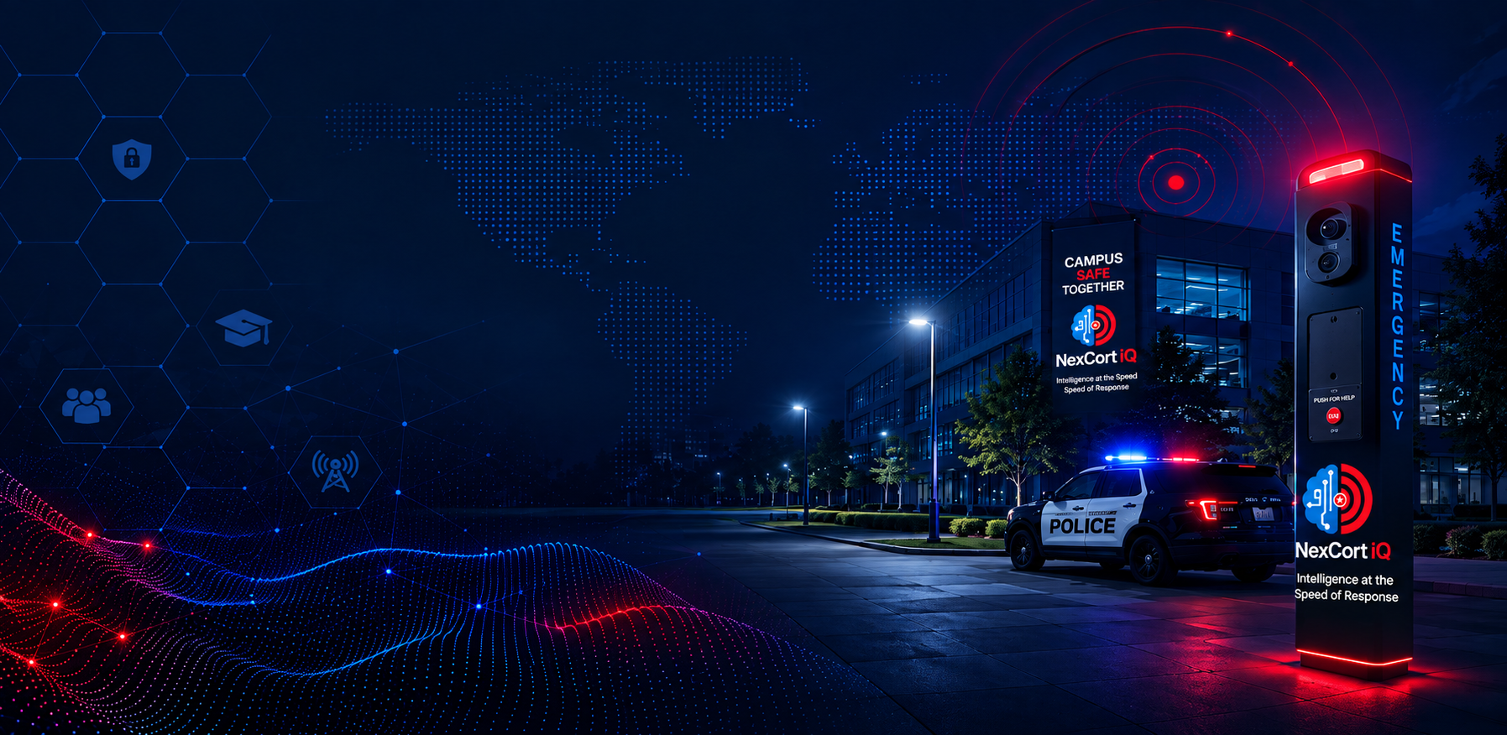

NC Campus — Safer People. Stronger Campuses.
Who buys it: VP Student Affairs · Campus Safety Directors · Title IX Coordinators · Provosts · Superintendents (K-12)
What it delivers: Campus safety console · QR/NFC + SMS reporting (no app) · two-way chat · photo/video intake · anonymous and identified reporting · Clery documentation (higher-ed) or Daily Incident Log & School Safety Report (K-12) · EAP/emergency checklists · NC Translate · tip analytics · Roles: CAMPUS_ADMIN, CAMPUS_SUPERVISOR, CAMPUS_SECURITY, CAMPUS_DISPATCH. (CAMPUS_COUNSELOR / CAMPUS_FACULTY are deprecated — do not assign.)
Key differentiators: Three reporting channels on one sign — QR + NFC + SMS. No app = zero adoption barrier. Clery module for higher-ed; K-12 uses Daily Incident Log and School Safety Report (not Clery ASR). Only campus safety platform with bidirectional AI translation.
Pricing: $1.40 per enrolled student per year · $5,000/year minimum.

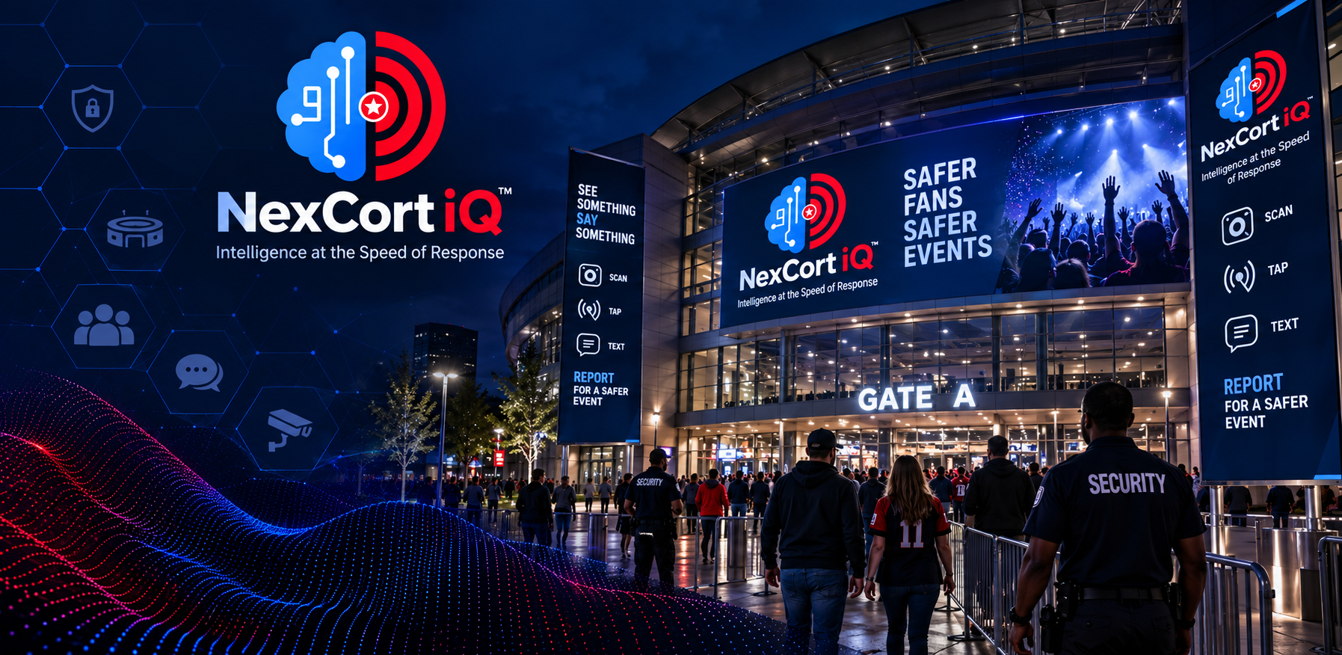

NC Venue — Safer Events. Smoother Operations.
Who buys it: VP Security/Operations · Event Safety Directors · Arena/Stadium GM · Convention Center Ops Managers
Venue types: Stadiums · arenas · convention centers · concert venues · airports · fairgrounds
What it delivers: Venue security command console · fan-to-security QR/NFC by zone/section/gate · SMS two-way chat · photo/video intake · camera/access integration · video wall · SOP/MCI action codes · NC Translate · optional Venue Guest Services console (non-911) · Roles: VENUE_ADMIN, VENUE_SUPERVISOR, VENUE_SECURITY, VENUE_OPERATOR, VENUE_GUEST_SERVICES.
Key differentiators: Most venue security focuses on cameras. NC iQ is the only platform built around frictionless fan-to-security communication. Any fan can report in 10 seconds without an app.
Pricing: Capacity-based annual. Under 5K: $18K/yr · 5K–20K: $28K/yr · 20K–50K: $45K/yr · 50K+: $72K/yr.

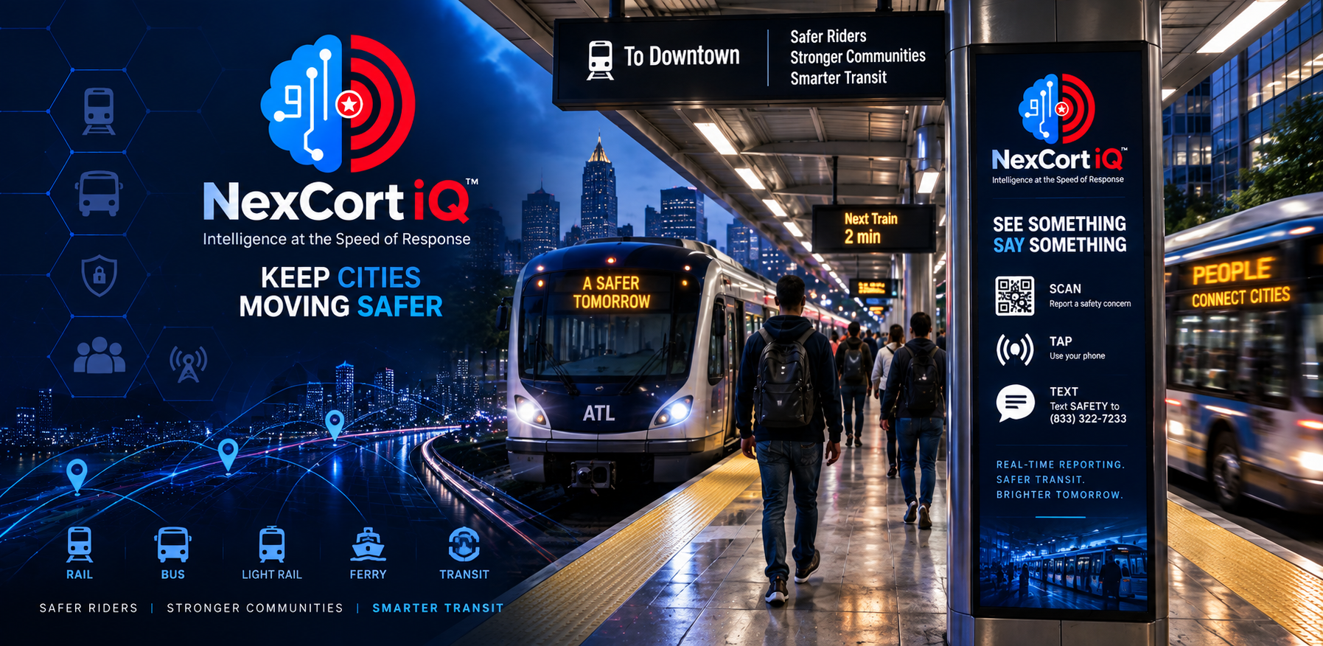

NC Transit — Keep Cities Moving Safer.
Who buys it: Transit Authority Security Directors · Operations VPs · Chief Safety Officers
Transit types: Bus · rail · light rail · ferry · shuttle networks
What it delivers: Transit security console · passenger QR/NFC on vehicles and at stations · SMS two-way chat · photo/video intake · fleet/vehicle/route management · transit operator view · camera integration · SOP/MCI location codes · Roles: TRANSIT_ADMIN, TRANSIT_SUPERVISOR, TRANSIT_SECURITY, TRANSIT_OPERATOR.
Pricing: Fleet-based annual. Under 50 vehicles: $18K/yr · 50–200: $32K/yr · 200–500: $52K/yr · 500+: $85K+/yr.

NC Hospital — EMS Coordination & Pre-Alert Intake
Who buys it: Hospital Safety Directors · EMS Coordinators · Chief Nursing Officers · ED Managers
What it delivers: Hospital staff console · EMS pre-alert intake · capacity/diversion board · MCI coordination tools · coordinator/EMS liaison views · QR-based internal staff safety reporting · incident timeline · Roles: HOSPITAL_ADMIN, HOSPITAL_STAFF (confirm HOSPITAL_COORDINATOR assignability before promising).
Pricing: Facility/bed-based annual. Under 100 beds: $18K/yr · 100–300 beds: $30K/yr · 300–600 beds: $48K/yr · 600+ beds: $75K+/yr.

Call Assist — AI-Powered Non-Emergency Call Handling
What it is: Separate from the 911 dispatcher workspace. Amazon Connect + Lex + Bedrock + Polly for non-emergency intake — greet, classify, callback, escalate. Emergency mid-call handoff uses hardcoded TRANSFER_911 that no admin setting can disable. Console: /app/call-assist/{admin|supervisor|operator} only.
Who buys it: Same 911 directors who buy NC 911 — for non-emergency volume reduction. Separate console at /app/call-assist/{admin|supervisor|operator} — never the 911 dispatcher workspace. Emergency mid-call handoff uses fail-closed TRANSFER_911.

5 · SKUs AND PRICING
⚠ INTERNAL USE ONLY — Public language: "Tailored deployment · Custom quote · Contact sales"

⚠ Never share these figures with prospects without Sales Director approval. Discounts over 15% require Sales Director sign-off. Enterprise pricing requires VP Sales + Sales Director approval before quoting.

NC 911 — Essential Plan (prices are subject to change w/o notice)
Small municipalities · Single-site PSAPs · Pilots · Up to 10 dispatcher seats
Tier | Seats | Calls/Mo | Monthly Fee | Annual | Pilot (90-day) | Implementation
Micro T1 | 1–3 | <2,000 | $2,800 | ~$33.6K | $25,000 | $10,000
Small T2 | 4–6 | 2K–3.5K | $4,200 | ~$50.4K | $30,000 | $15,000
Medium T3 | 7–8 | 3.5K–4.5K | $5,400 | ~$64.8K | $37,500 | $20,000
Large T4 | 9–10 | 4.5K–5K | $6,000 | ~$72K | $50,000 | $25,000
Seat overages: Dispatcher $150/seat/mo (seat 11+) · Admin/Supervisor $100/seat/mo (seat 4+). Best for grant-funded pilots and first-reference opportunities.

NC 911 — Professional Plan (prices are subject to change w/o notice)
Growing counties & cities · Full features · Translation included · QA included · Up to 25 seats
Tier | Seats | Calls/Mo | Monthly Fee | Annual | Pilot (90-day) | Implementation
Small Pro T1 | 1–10 | <10,000 | $8,500 | $102K | $50,000 | $25,000
Med Pro T2 | 11–18 | 10K–18K | $13,000 | $156K | $70,000 | $40,000
Large Pro T3 | 19–23 | 18K–23K | $15,500 | $186K | $87,500 | $50,000
Max Pro T4 | 24–25 | 23K–25K | $18,000 | $216K | $100,000 | $60,000
Live Translation, Caller Photo/Video Upload, Media Audit Trail, QA Tools, and Priority Support are included — not add-ons. Seat overage: $125/seat/mo.
NC 911 — Command Plan (prices are subject to change w/o notice)
Large agencies · Regional command · Major incident coordination · Up to 75 seats
Tier | Seats | Calls/Mo | Monthly Fee | Annual | Pilot (90–180d) | Implementation
Small Cmd T1 | 1–25 | <30,000 | $22,500 | $270K | $100,000 | $75,000
Med Cmd T2 | 26–50 | 30K–60K | $31,000 | $372K | $150,000 | $100,000
Large Cmd T3 | 51–65 | 60K–85K | $40,000 | $480K | $200,000 | $125,000
Max Cmd T4 | 66–75 | 85K–100K | $50,000 | $600K | $250,000 | $150,000
Adds over Professional: Major Incident Management · Command Dashboard · War Rooms · Runbooks/Playbooks · Stakeholder Pages · Alert Correlation · SLO Dashboards · Premium Onboarding. Seat overage: $100/seat/mo.

NC 911 — Enterprise / Statewide (prices are subject to change w/o notice)
Size | Agencies | Seats | Monthly | Annual
Small Enterprise | 2–5 | 50–150 | $60K–$100K | $720K–$1.2M
Medium Enterprise | 6–15 | 150–300 | $100K–$175K | $1.2M–$2.1M
Large Enterprise | 16–30 | 300–500 | $175K–$250K | $2.1M–$3M
Statewide | 30+ | 500+ | $250K+ | $3M–$10M+
Implementation: $150K–$750K one-time per SOW. Every Enterprise deal requires a custom SOW and VP Sales + Sales Director approval before quoting.

Vertical Pricing Summary (prices are subject to change w/o notice)
Vertical | Pricing Model | Entry Price | Top of Range | Min Contract
NC 911 | Per seat/month | $2,800/mo | $50,000/mo | None stated
NC Campus | $1.40/enrolled student/yr | $5,000/yr | Scales with enrollment | $5,000/yr
NC Venue | Capacity-based annual | $18,000/yr | $72,000+/yr | None stated
NC Hospital | Facility/bed-based annual | $18,000/yr | $75,000+/yr | None stated
NC Transit | Fleet-based annual | $18,000/yr | $85,000+/yr | None stated

Key Add-Ons

CAD Integration (one-time fees) (prices are subject to change w/o notice)
Tier | Read-Only | Assisted Write-Back
Tier 1 — Simple | $35,000 | $75,000
Tier 2 — Standard | $55,000 | $125,000
Tier 3 — Complex | $75,000 | $175,000
Tier 4 — Advanced | $100,000 | $250,000
CAD Discovery Workshop: $7,500–$15,000 (recommended first step). Do NOT include full write-back in pilot base pricing — scope separately after discovery.

Feature Add-Ons — Monthly (prices are subject to change w/o notice)
Add-On | Monthly Range | Notes
Agency Share | $1,500/mo per agency | Consent-based cross-agency incident awareness. Available: NC 911, NC Campus, NC Hospital.
NC Connect — Standard (10 cameras) | $500–$1,500/mo | ONVIF/RTSP camera integration
NC Connect — Professional (50 cameras) | $1,500–$4,000/mo | Multi-zone camera management
NC Connect — Enterprise (unlimited) | $4,000–$12,000/mo | Large deployments
Citizen Camera Share | $500–$1,500/mo | Time-limited WebRTC share via SMS link
SMS Location Acquisition | $500–$2,000/mo | Auto-reply GPS link on SMS intake
AI Triage Workflows | $2,500–$7,500/mo | Basic (5–10 rules) → Premium (25+ rules, all types)
AI Incident Summarization | $1,500–$5,000/mo | By call volume tier (<5K, 5K–20K, 20K+/mo)
Live Translation (Essential tier) | $1,000–$3,000/mo | Included in Professional+
Enhanced Transcription Accuracy | $1,500–$5,000/mo | By call volume tier
Priority Support | $1,000–$3,000/mo | Included in Professional+. 4-hr response SLA, named contact.
Dedicated Support Engineer | $8,000–$20,000/mo | Command+ add-on.

6 · COMPETITIVE POSITIONING

NC iQ is not a CAD system, telephony system, or investigative RTCC. It is an intelligence layer — it sits above all of them and enhances what dispatchers and supervisors see and do during an active call or incident.

Competitor | What They Do | How NC Wins
RapidSOS | Caller data enrichment (location, medical, sensor) passed to CAD at call connect. Primarily a data pipe into CAD. | NC delivers a full dispatcher workspace — transcription, AI coaching, translation, video, QA, command tools. RapidSOS feeds CAD; NC wraps the dispatcher.
Axon Fusus | Investigative RTCC for post-incident investigation and camera sharing. | NC is incident-driven, call-driven, and ECC-focused. Fusus is an investigative tool for detectives. Different buyer, different use case. NC can run alongside it.
Motorola / PremierOne | CAD system and analytics (PremierOne, CommandCentral, VESTA). | NC positions as a complementary intelligence layer over Motorola CAD — enhancing the dispatcher without disrupting CAD workflow.
Carbyne | NG911 caller engagement — video, location, multimedia. | NC offers the full dispatcher and supervisor workspace; Carbyne is caller-engagement only. NC includes equivalent capabilities as features.
Language Line / Interpreter Services | Phone interpreter holds — average 3–5 minute wait. | NC Translate is live, bidirectional, no hold time. No interpreter. No third party on the call.
Raptor Technologies | K-12 visitor management and safety software. | NC Campus is a broader safety reporting and incident management platform, with planned K-12 pre-door NSOPW + state sex offender check that Raptor cannot match.

Common Objections & Responses

"We already have CAD. Why do we need this?"
CAD is your dispatch system. NC is your intelligence layer. CAD logs the call. NC helps the dispatcher understand the call in real time while it's happening — transcription, translation, caller location, video, AI coaching — before anything hits CAD. Then NC helps write the CAD entry, dispatcher-reviewed.

"Our dispatchers are trained professionals. They don't need AI."
NC doesn't tell dispatchers what to do. It surfaces information faster. On a Spanish-speaking call, NC gives a translated transcript in real time — the dispatcher still runs the call. During a major incident, Surge View clusters calls so the supervisor sees the pattern 90 seconds before anyone calls it in. Co-pilot, not autopilot.

"We're concerned about CJIS compliance."
NC is CJIS-aware by design: RBAC, 7-year audit log retention, MFA on every account, no cross-agency data access without explicit consent, AWS us-east-1 with KMS encryption at rest. SOC 2 Type II documentation substantially complete. We provide a full security documentation package.

"We can't afford a new system right now."
Essential starts at $2,800/month for up to 3 seats — less than a part-time interpreter service. Pilot programs available with pre-packaged pricing. Many agencies use JAG, COPS, or PSAP technology grants. We can help identify applicable grants.

"We need five agency references and you're too new."
We own it. We are actively signing pilot agencies. We offer a 90-day structured pilot with performance guarantees, side-by-side with your existing CAD, with no disruption to current operations. One signed pilot closes this door for every future RFP cycle.

"What happens if your system goes down?"
NC is an enhancement layer — if NC is unavailable, dispatchers operate exactly as they do today. NC does not sit in the call path. AWS multi-AZ redundancy, CloudFront edge distribution, DynamoDB continuous backups. Downtime does not break 911 operations.

"We need to check with our CAD vendor first."
We encourage it. NC currently supports read-only integration with all major CAD vendors. Write-back requires a separate scoping engagement. We start with read-only — no changes required from the CAD vendor except read access to the feed. We have worked through the discovery process with agencies running Tyler, CentralSquare, Hexagon, and Spillman.

7 · SALES PROCESS

Stakeholder Map — Know Your Buyer
Vertical | Economic Buyer | Technical Evaluator | Champion
NC 911 | PSAP Director / County Manager | IT Director / CTO | Lead Dispatcher or QA Supervisor
NC Campus | VP Student Affairs / Provost | Campus IT Director | Campus Safety Director
NC Venue | VP Operations / GM | IT/AV Director | Security Operations Manager
NC Transit | Chief Safety Officer / COO | IT Director | Security Director
NC Hospital | CNO / VP Operations | IT Director | ED Manager or EMS Coordinator
Rule: Always identify the Economic Buyer and the Champion separately. The champion opens doors; the economic buyer signs the check. Get to both.

Deal Stages
Stage | Goal
1. Outreach / Discovery | Identify the right stakeholder, secure a 30-minute intro call. Confirm vertical fit and pain point.
2. Discovery Call | Run the discovery question framework. Qualify budget, timeline, decision process. Identify the champion.
3. Demo / Capability Walk | Product demo tailored to their vertical and pain points. Confirm technical fit. Surface objections.
4. Proposal | Recommend a plan + pilot. Never quote Enterprise without Sales Director sign-off. Include CAD discovery workshop if in scope.
5. Pilot Agreement | Close a 90-day (or 90–180-day for Command) structured pilot. This is the signature that closes the reference gap.
6. Pilot → Full Contract | Convert to annual agreement. Use pilot performance data (transcription accuracy, call time, QA score) as proof points.

Key Discovery Questions — NC 911
• How many dispatcher seats do you run per shift? Total?
• What CAD system are you on? Tyler, CentralSquare, Hexagon, Spillman — or something else?
• Approximate call volume per month / per year?
• Do you currently have live transcription or call recording capability?
• What languages other than English are most common in your service area?
• What does your QA process look like today — manual review, scored, or ad hoc?
• How do you handle situations where the caller cannot speak or will not speak?
• Has your agency explored NG911 upgrades? Where in that process?
• What is your biggest operational challenge in the dispatch center right now?
• What does your budget cycle look like? Is grant funding available for tech upgrades?

Key Discovery Questions — NC Campus
• How does a student or staff member report a safety concern today?
• Higher-ed: Do you track incidents for Clery Act compliance? How? K-12: How do you log daily incidents / school safety reports today?
• What percentage of your campus community would report via QR code vs. a mobile app?
• What are your most common incident types? (Mental health, theft, harassment, medical?)
• Do you have a campus safety app currently? What is your adoption rate?
• How does campus security communicate with local law enforcement during an incident?

Grant Funding Opportunities
Grant / Program | Notes
JAG (Justice Assistance Grant) | Federal formula grant for law enforcement and justice technology. Can fund dispatch technology.
COPS Technology Grants | Office of Community Oriented Policing Services — technology modernization.
PSAP Improvement Funds | State-administered surcharge funds from 911 fees. Many states allow technology investments.
FEMA BRIC / HMGP | Hazard Mitigation Grant Programs — incident coordination tools may qualify.
E-Rate (Campus) | FCC program for schools and libraries. Technology-eligible.
COPS School Safety | K-12 school safety technology grants.

8 · COMPLIANCE AND SECURITY

Public safety buyers are risk-averse. Compliance language is a gate, not a feature. Get it right before the first call.

Situation | Say This | Do NOT Say
CJIS compliance | "NC iQ is designed with CJIS alignment — RBAC, audit logging, MFA, encrypted data at rest and in transit." | "We are CJIS certified" — we are not yet
SOC 2 | "Our SOC 2 Type II documentation corpus is substantially complete. Final stages of formal certification." | "We are SOC 2 certified" — not yet
Data sovereignty | "All data is stored in AWS us-east-1. We do not route data outside that region." | Never imply offshore or multi-cloud routing
AI and decisions | "Every AI recommendation is shown to the dispatcher for review. AI does not take action autonomously." | "AI handles it automatically"
CAD write-back | "Fail-closed by default. Only enabled after a signed agency addendum and explicit configuration." | Volunteering write-back as a selling feature too early

Security Architecture
Area | Detail
Infrastructure | AWS us-east-1 — Lambda, DynamoDB, API Gateway, ECS Fargate, Cognito, KVS, Bedrock, Amazon Location Service.
Authentication | Amazon Cognito with MFA enforced on all accounts. SSO-ready via SAML/OIDC.
Authorization | RBAC — every permission is agency-scoped. No cross-agency data access without Agency Share enrollment and dual admin approval.
Encryption | AWS KMS encryption at rest. TLS in transit. All media (photo, video, transcripts) encrypted separately.
Audit Logging | Every user action, cross-agency read, and system event logged. 7-year retention on government compliance records.
Data Isolation | Each agency's data is logically isolated. DynamoDB partition key design enforces tenant separation.
CAD Safety | CAD write-back is fail-closed by default (signed addendum required). Call Assist emergency handoff (TRANSFER_911) is separately hardcoded and cannot be suppressed.
SOC 2 Status | 16+ policies documented · Asset register complete · ISO 27001 SOA complete · CPA firm procurement pending · Expected certification early 2027.
Clery Act (Campus) | Higher-ed: Clery review queue, Daily Crime Log (Daily Incident Log in UI), ASR tooling. K-12: Daily Incident Log and School Safety Report (not a Clery ASR). Advanced Clery Reporting add-on (higher-ed): $4,000–$10,000/yr.

9 · DEMO TIPS AND PROOF POINTS

The 30-Minute Demo Sequence — NC 911
Step | What to Do
1. Open the live dispatcher console | Show the incident queue and caller card. Say: "This is what the dispatcher sees — not instead of CAD, alongside it."
2. Simulate a 911 call | Show live transcription appearing word by word. Say: "Every word is captured in real time — no recall, no notes, just the transcript."
3. Switch to a Spanish-speaking caller | Show NC Translate deliver the translation live. Say: "No interpreter. No hold. The dispatcher hears English. The caller speaks Spanish. It works in both directions."
4. Show Video Assist | Request live video from the caller. Say: "WebRTC — no app download. The dispatcher sees what the caller sees within seconds."
5. Show Live Caller Location | Show GPS pin with accuracy radius and Live/Stable/LOST status. Say: "We surface location confidence — not just a coordinate."
6. Show the Supervisor QA Dashboard | Show active call monitoring and QA scoring. Say: "The supervisor sees everything — not after the call, during it."
7. Close with Surge View | Show clustered incidents on the map. Say: "NC clusters calls automatically. The supervisor knows it's a major incident before anyone calls it in."
Timing: Steps 1–4 = 15 min · Steps 5–7 = 10 min · Questions = 5 min. Full screen only. No distractions.

The 20-Minute Demo — NC Campus
Step | What to Do
1. Show the campus safety console | Incident map with zone overlays.
2. Scan a QR code | Open the intake form on a phone — no app install. Zone and location pre-filled automatically.
3. Submit a photo with the report | Show it land in the console attached to the incident record in real time.
4. Show two-way chat | Dispatcher ↔ student, with AI translation live.
5. Show compliance reporting (Clery for higher-ed; Daily Incident Log / School Safety Report for K-12) | One click export. End with: "Higher-ed ASR path — for K-12 use Daily Incident Log / School Safety Report, not Clery ASR."

Memorable Proof Points
Claim | What to Say
Language access | "100+ languages. Live. Bidirectional. No interpreter on hold."
Speed | "Caller location acquired in under 0.3 seconds on GPS-capable calls."
Adoption (Campus) | "No app download. Any smartphone camera. QR + NFC + SMS. Three channels. One sign."
CAD safety | "Fail-closed by default. The dispatcher reviews every AI suggestion before it hits CAD."
Infrastructure | "Built on AWS — same infrastructure used by federal agencies, healthcare systems, and the intelligence community."
Cognitive load | "NC doesn't add to the dispatcher's workload. It reduces it. The transcript is written. The location is on the map. The language is translated."
Mass casualty | "Surge View clusters calls by time, place, and type. The supervisor sees the pattern before anyone declares a major incident."

Dos and Don'ts
✓ DO | ✗ DON'T
Personalize the demo scenario to their actual call types (MVC, EDP, welfare check). | Open with a feature list.
Reference their CAD system by name if you know it. | Demo features they don't need.
Pause after each feature and ask "What questions do you have about this?" | Over-promise on CAD write-back.
Know your audience: PSAP Director wants outcomes; IT Director wants architecture. | Claim CJIS certification or SOC 2 certification. We are in progress. Say it accurately.
Open with a problem: "When a Spanish-speaking caller reaches your PSAP, what happens today?" | Demo in a tab next to your email. Full screen. No distractions.

After the Demo — Next Steps
1. Send the capability overview document within 24 hours.
2. Offer a CAD Discovery Workshop ($7,500–$15,000) if CAD integration is in scope.
3. Propose a 90-day structured pilot — pre-packaged pricing, clear success metrics, defined exit criteria.
4. Connect the prospect's IT Director with NC iQ's security documentation package.
5. If grant funding is relevant, provide the grant guidance one-pager.

10 · OFFERABLE FEATURE CATALOG — IN-DEPTH
Use this catalog with the in-product Pricing Catalog (/sales/pricing-catalog). Definitions are feature-only for sales contractors — no list prices in the portal. Quote Builder and Sales Director approval govern commercial numbers. Never-free items must not appear as complimentary on any order or pilot.

How to use these definitions
1) Lead with buyer outcome, not SKU name. 2) Confirm vertical fit before promising a feature. 3) Mark never-free items (live transcription, AI triage, CAD write-back, CAD mesh, NexIQ Vision™) as paid always. 4) Use free offerings as wedges, not as the whole deal. 5) If unsure whether a SKU is live, say you will confirm — do not invent availability.

Feature | Category | Verticals | In-depth definition
NexCort iQ Community Connect | Free offerings | Campus · Venue | Permanent free tip line: one QR, one zone, email forward only. No console, chat, AI, or Clery. Land-and-expand wedge after adoption proof.
Complimentary Operational Intelligence Report | Free offerings | All verticals | One-time: 30–60 days anonymized CAD export → 3–5 page PDF (volume by hour, call mix, language %, peaks). Limited availability discovery accelerator.
NexCort iQ Wellness | Free offerings | 911 / PSAP | Anonymous 60-second end-of-shift check-in. Supervisors see aggregates only — no call data/CJIS. Free for accredited PSAPs.
Live transcription | 911 Centers / PSAPs | 911 / PSAP | Real-time word-by-word STT in the dispatcher workspace. Foundation for coaching, QA, and summaries. Core differentiator — never free.
AI-assisted triage & confidence scoring | 911 Centers / PSAPs | 911 / PSAP | Live advisory triage/SOP/confidence cues from the transcript. Human decides. Never free.
CAD read-only integration | CAD Integration | 911 / PSAP | One-way CAD enrichment into NC context. Safe first step with Tyler, CentralSquare, Hexagon, Spillman, etc.
CAD write-back | CAD Integration | 911 / PSAP | Dispatcher-reviewed posting into native CAD. Fail-closed; signed addendum required. Never free; never in pilot base without discovery.
CAD-to-CAD mesh | CAD Integration | 911 / PSAP | Regional mutual-aid CAD mesh. High trust/complexity. Never free; not a single-agency pilot promise.
Transcription & translation | Language | 911 · Campus · Venue | Multi-language STT + live translation assist for telecommunicators. Emphasize no interpreter hold.
NexCort Translate | Language | All verticals | Field/ops voice translation for campus, venue, transit, clinical — language access at the point of contact.
Caller media intake | Media | 911 · Campus · Venue · Transit | Secure SMS/web media upload — photos/video/location — no citizen app. Audit-trailed into the incident.
Supervisor QA & coaching | Quality | 911 / PSAP | Scorecards, coaching notes, post-incident review tied to transcript and timeline.
Team performance dashboards | Analytics | 911 · Campus · Venue · Transit | Shift/team KPIs for supervisors and leadership after go-live.
Tip & incident analytics | Analytics | Campus · Venue · Transit | Trends on tip volume, types, hotspots, response intervals for board/staffing stories.
Command dashboard & war rooms | Command | 911 · Campus · Venue | Command SA and war-room collaboration for major incidents without crowding the dispatcher seat.
Mutual Aid & MCI Command | Command | 911 · Hospital | Mutual aid + MCI coordination tooling across PSAP/hospital participants.
Security / tip console | Campus & Venue | Campus · Venue · Transit | Full tip inbox: assignment, status, two-way chat — paid upsell beyond Community Connect email-only.
Clery documentation log | Campus & Venue | Campus | Higher-ed Clery/daily crime log workflows. K-12: Daily Incident Log & School Safety Report — not Clery ASR.
Multi-zone QR / NFC | Campus & Venue | Campus · Venue · Transit | Multiple zones + NFC beyond the free single-zone tip line. Seat/building/vehicle context pre-filled.
Venue Guest Services console | Campus & Venue | Venue | Orange-branded non-911 guest-services console. Explicitly not a 911 dispatch system.
Hospital capacity portal | Hospital | Hospital · 911 | ER capacity, diversion, EMS pre-alert coordination for hospitals and regional partners.
Transit operations console | Transit | Transit | Route/zone ops, passenger reports, transit security workflows — not a rebranded PSAP seat.
Call Assist (non-emergency) | Call Assist | 911 · Campus · Venue · Transit | AI non-emergency intake + operator console. TRANSFER_911 hardcoded. Never lands on 911 dispatcher UI.
NexIQ Vision™ | Vision & Cameras | 911 · Campus · Venue · Transit | Live camera assist + scene intelligence + vision transcripts. Never free. Human-in-the-loop.
Nest / Wyze Connect | Vision & Cameras | 911 · Campus · Venue | Citizen Nest/Wyze share alongside Ring into the incident — temporary consent-based view.
NG911 Assist | 911 Centers / PSAPs | 911 / PSAP | Diversion, EIDO/additional data, NG911 metrics for i3-aware agencies. Not a telephony rip-and-replace.
API access | Platform | All verticals | Programmatic APIs for BI/reporting/middleware. Sell to IT after product fit is clear.
Premium support | Support | All verticals | Elevated SLA + named success contact. Often included in Professional+; confirm SOW language.
Setup & implementation | Implementation | All verticals | Remote setup, config, admin training. Keep complex CAD/radio/camera as separate discovery lines.
Onsite deployment & training | Implementation | All verticals | On-floor training and go-live support. Scope shifts, travel, train-the-trainer in the SOW.
NexiQ sales & RFP intelligence | Sales Intelligence | Internal only | Internal RFP/PSAP signal pipeline for NexCort sales — not an agency-facing SKU. Do not sell to customers.

Additional Discovery Questions — Venue / Transit / Hospital
NC Venue: How do fans report issues today? Seat/section/gate labeling? Security vs guest-services split? Peak event capacity? Camera/VMS vendor? Union or contracted security?
NC Transit: Fleet size by mode? On-vehicle vs station reporting need? CAD/AVL vendor? After-hours security model? Rider language mix?
NC Hospital: Diversion frequency? EMS pre-alert process today? Bed/ED capacity visibility? MCI drills with local PSAP? Internal staff safety reporting?

Sales Contractor Access (Internal)
Role salescontractor: Sales Portal, deployments map, leads/signals/PSAP prospects/contacts, NexiQ/intel, campaigns, conferences, feature catalogs (no prices), document library, notices, grants, onboarding packets, system health. Do NOT expect Agencies, Users, Billing, Invoices, Feature Flags, Audit, Hiring ATS, or live Pricing Admin with dollar amounts.
Public language for price: “Tailored deployment · Custom quote · Contact sales.” Never email rate tables from Section 5 without Sales Director approval.
Sales Contact: JwColeman@nexcortiq.us · (404) 520-1747 · www.nexcortiq.us · Ops: app.rapidcortex.us

FULL PLATFORM CAPABILITY OVERVIEW

NexCort iQ — One Platform. A Safer Tomorrow. Reference capability map for all verticals, integrations, and client surfaces.

